Name: _________________ Date: __________________

Complete the worksheet using the correct comparative or superlative.

1) Saturn is __________ than Earth but Jupiter is ____________.

a) | big | b) bigger | c) biggest
2) | Mercury is the ____________ planet in the Solar System.
a) | small | b) smaller | c) smallest
3) | Mercury is the __________ planet in the Solar System.
a) | hot | b) hotter | c) hottest
4) | Mars is ___________ to Earth than Uranus.
a) | close | b) closer | c) closest
5) | The moon is ___________ but the sun is ____________.
a) | bright | b) brighter | c) brightest
6) | Venus is _________ from Earth but Neptune is ___________.
a) | far | b) farther | c) farthest
7) | Neptune is ___________ but Uranus is ____________.
a) | cold | b) colder | c) coldest
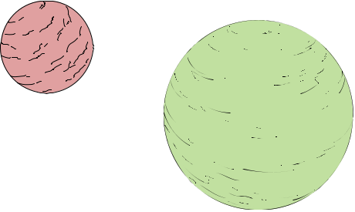
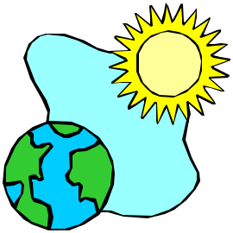

Copyright © 2009 www.eslkidsworld.com

