Comparison of adjectives, adverbs of manner

A Complete the sentences with the correct comparative form of the adjective in brackets.

1 | An elephant is ............................................ | stronger than | (strong) a kangaroo.
2 | Our teacher is ............................................ |  | (beautiful) that film star.
3 | A school is ............................................ |  | (noisy) a hospital.
4 | Jane’s hair is ............................................ |  | (long) yours.
5 | John’s work is ............................................ |  | (good) Mary’s.
6 | Yesterday was ............................................ |  | (hot) today.
7 | This book is ............................................ |  | (interesting) that one.
8 | Athletes are usually ............................................ |  | (famous) scientists.

B Write sentences about the pictures. Use the superlative form of the adjective.
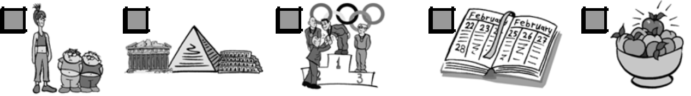

1 | 2 | 3 | 4 | 5

The girl is the tallest of the three.
1 the girl / tall / of the three ..................................................................................................................

2 the pyramid / ancient / of the three ..................................................................................................

3 this athlete / good / athlete in the world ..........................................................................................

4 February / short / month / in the year ................................................................................................

5 the red apple / sweet / apple in the bowl ........................................................................................

C Circle the correct word.

- I think Albert Einstein was the brilliant / more brilliant / most brilliant scientist in the world.

2 I am a good / better / best swimmer than my brother.

3 Mum is the busy / busier / busiest person in the family.

4 What is the most expensive / more expensive / expensive car in the world?

5 London is rainy / rainier / rainiest than Athens.

6 The book was frightening / more frightening / most frightening than the film.

D | Write adverbs for the adjectives.
 | Adjective | Adverb
1 | dangerous | dangerously
 |  | ......................
2 | nice | ......................
3 | fast | ......................
4 | happy | ......................
5 | good | ......................

E Circle the correct word.

1 The dog is eating hungry / hungrily .

- Is she drinking the hot coffee slow / slowly?

3 Sue is a nice / nicely person.

4 Tom plays tennis good / well.

5 The music was very loud / loudly.

6 The old lady spoke soft / softly.

6 quiet ......................

ESO 2 Photocopiable © B Burlington Books

Comparison of adjectives, adverbs of manner – Answers

- 1 stronger than

2 more beautiful than

3 noisier than

4 longer than

5 better than

6 hotter than

7 more interesting than

8 more famous than

- 1 The girl is the tallest of the three.

2 The pyramid is the most ancient of the three.

3 This athlete is the best athlete in the world.

4 February is the shortest month in the year.

5 The red apple is the sweetest apple in the bowl.

- 1 most brilliant

2 better

3 busiest

4 most expensive

5 rainier

6 more frightening

D | 1 | dangerously | 3 | fast | 5 | well
 | 2 | nicely | 4 | happily | 6 | quietly
E | 1 | hungrily | 3 | nice | 5 | loud
 | 2 | slowly | 4 | well | 6 | softly

ESO 2 Photocopiable © B Burlington Books

